HOMEWORK 7
Completa el cuadro
Specialist | Conditions
Neurologist
 | Sinusitis, tonsillopharingitis
Pneumatologist
 | Diabetes
Cardiologist
 | Constipation, Diarrhea
Psychiatrist

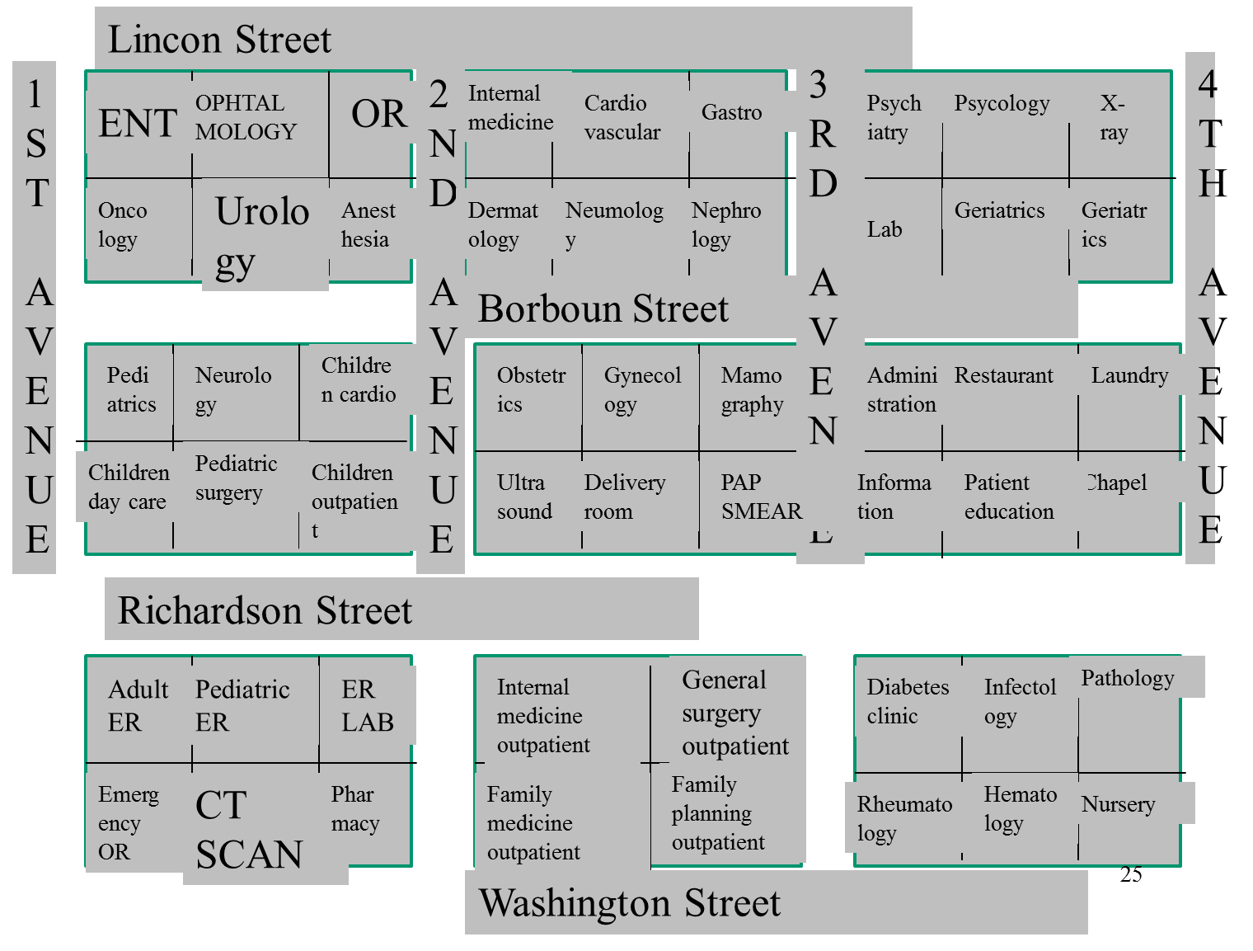
Usando el mapa responde a las preguntas

What’s the address of:
- Neurology
- Gastro
- General surgery outpatient

How do I get from
- The infectology deparment to the Neurology
- The diabetes clinic to CT Scan deparment
- Chapel to the Pharmacy
Problems
- Andrea went to the diabetes clinic and now she needs to get her insulin
  - Where should she go?
  - Explain Andrea how to get there from the diabetes clinic
- Robert is a child with seizures one day he had an event and his mother took him to the Pediatric ER now he is stable and needs to consult with the specialist
  - Where should Robert go for proper attention?
  - Explain Robert and his mother how to get there from the Pediatric ER

